CS 255 System Design Document Template

UML Diagrams

UML Use Case Diagram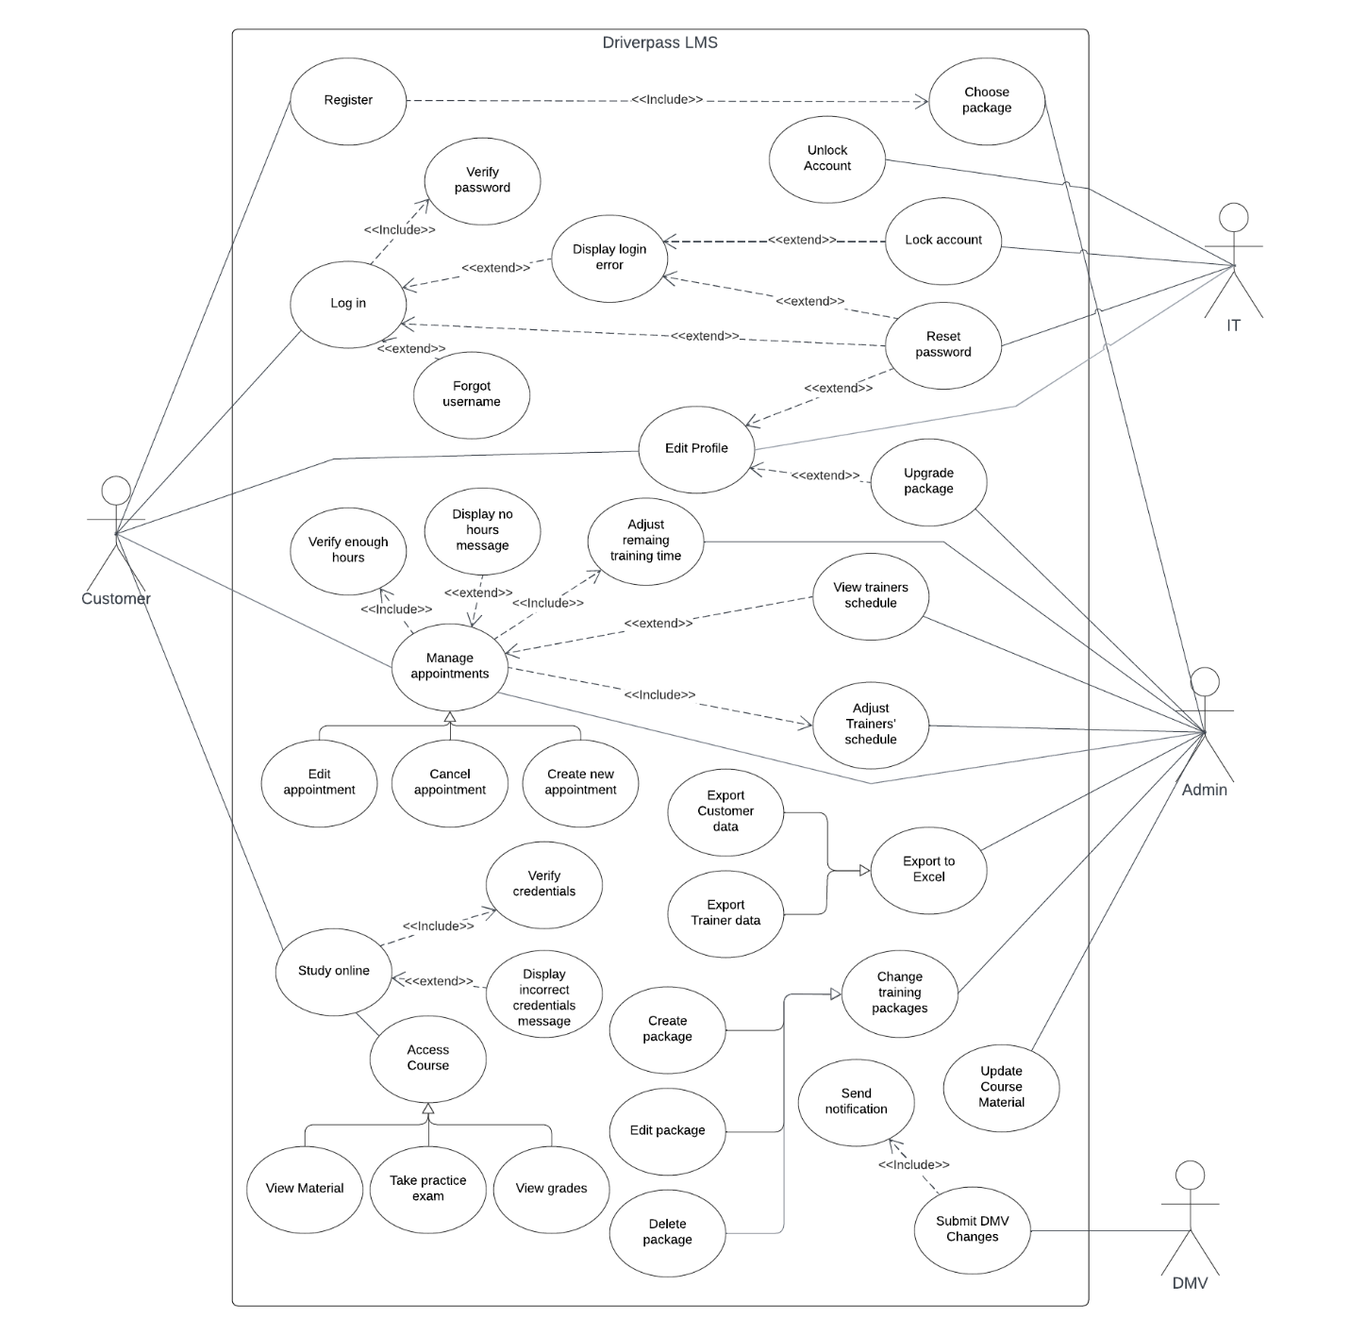

UML Activity Diagrams

UML Sequence Diagram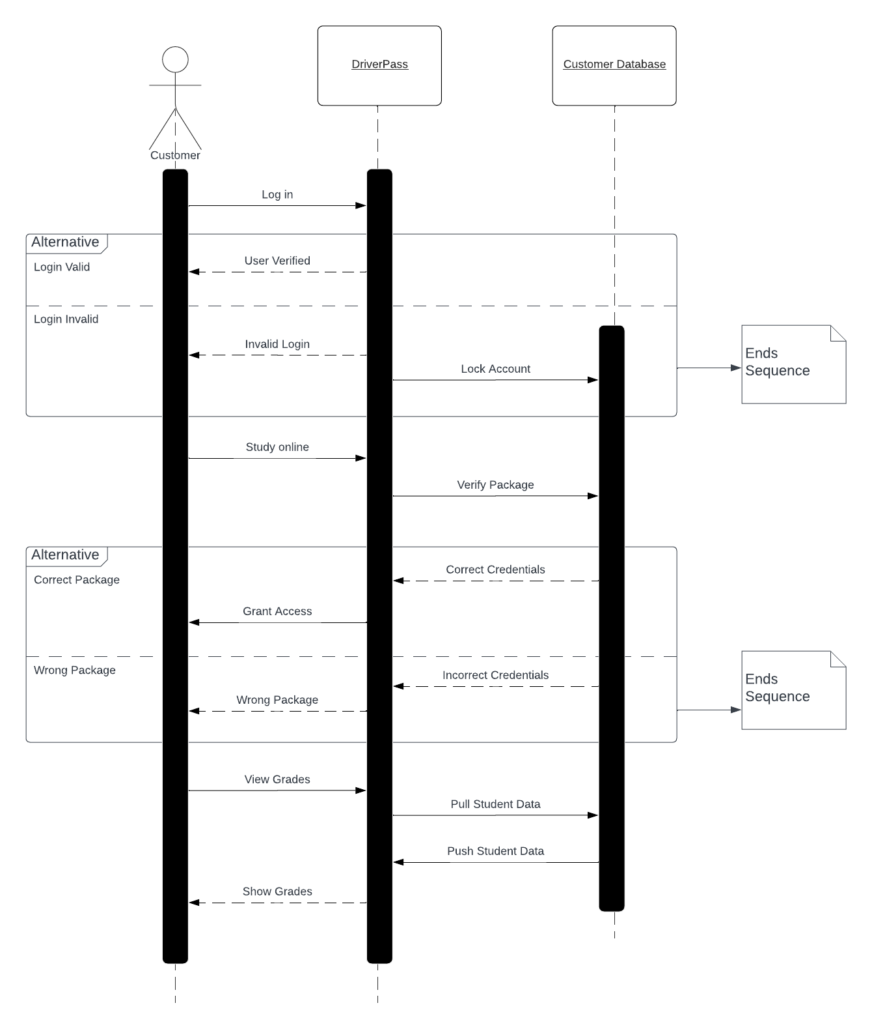
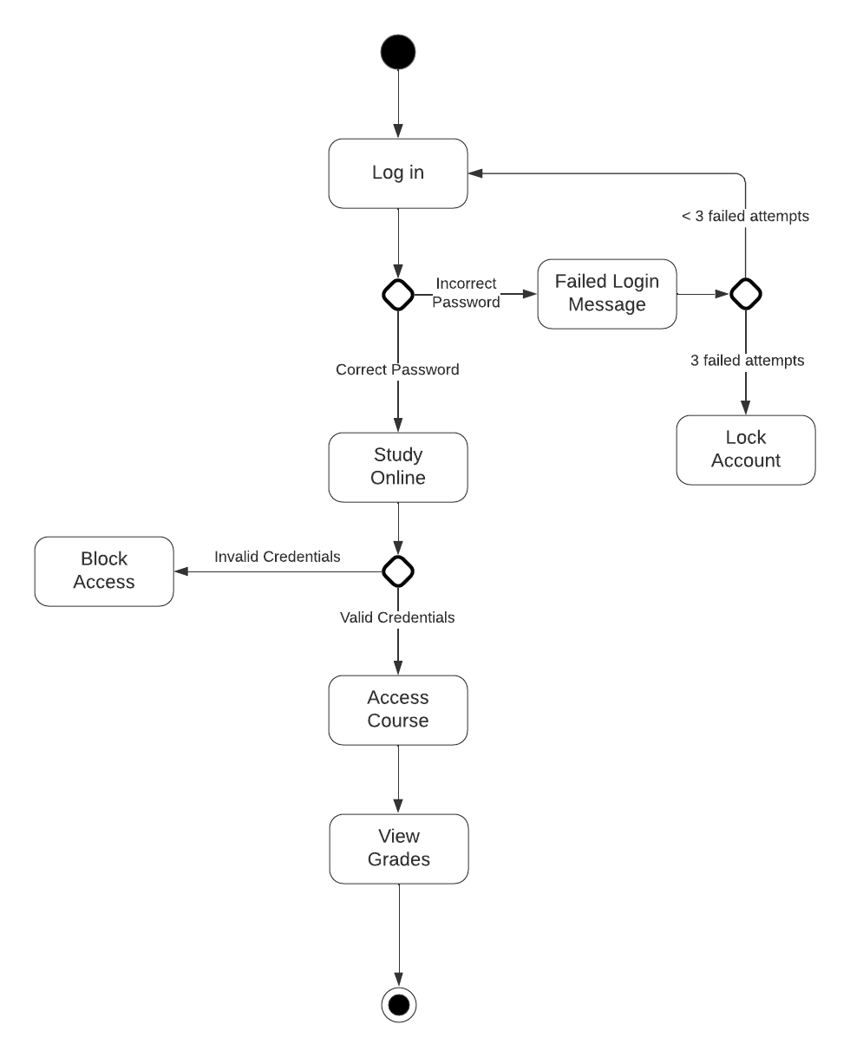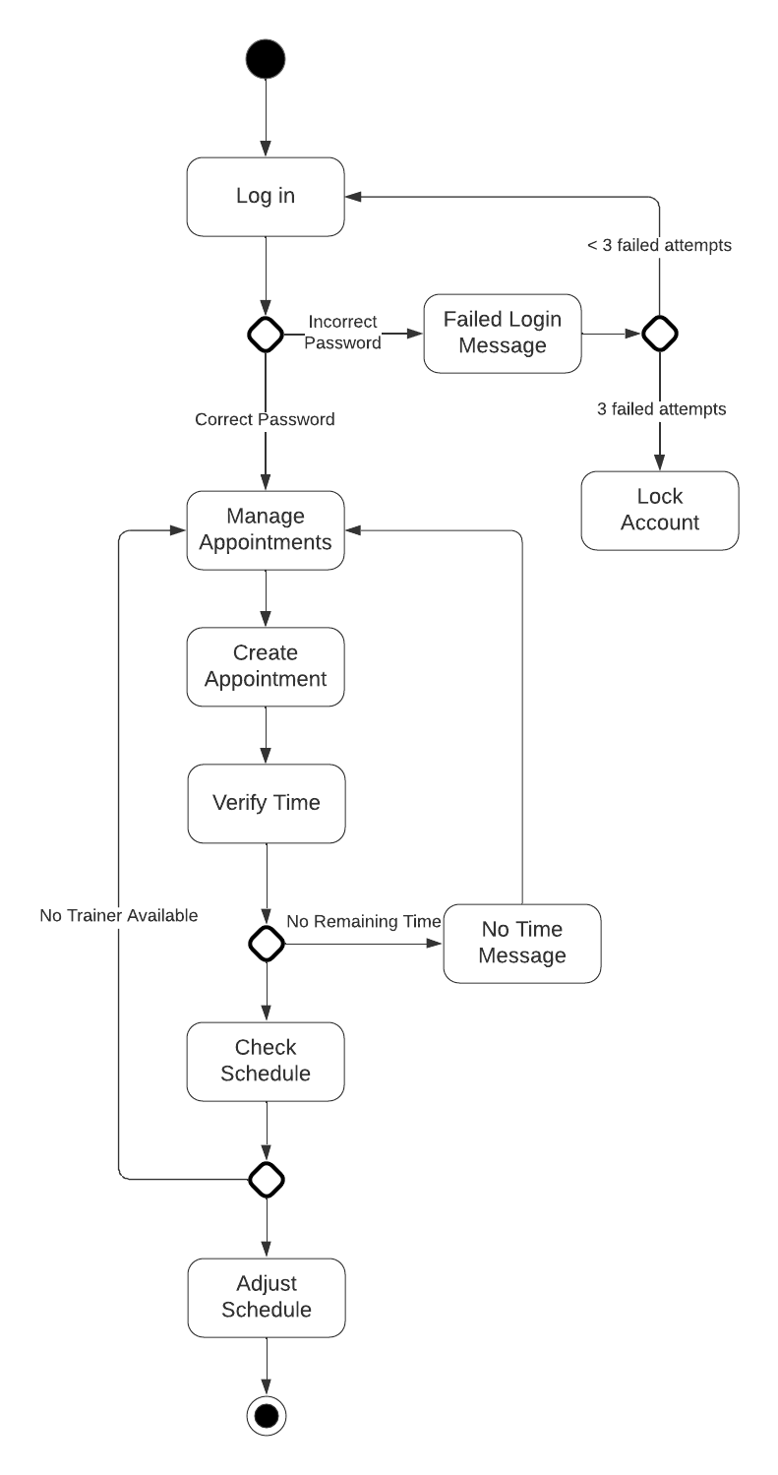

UML Class Diagram
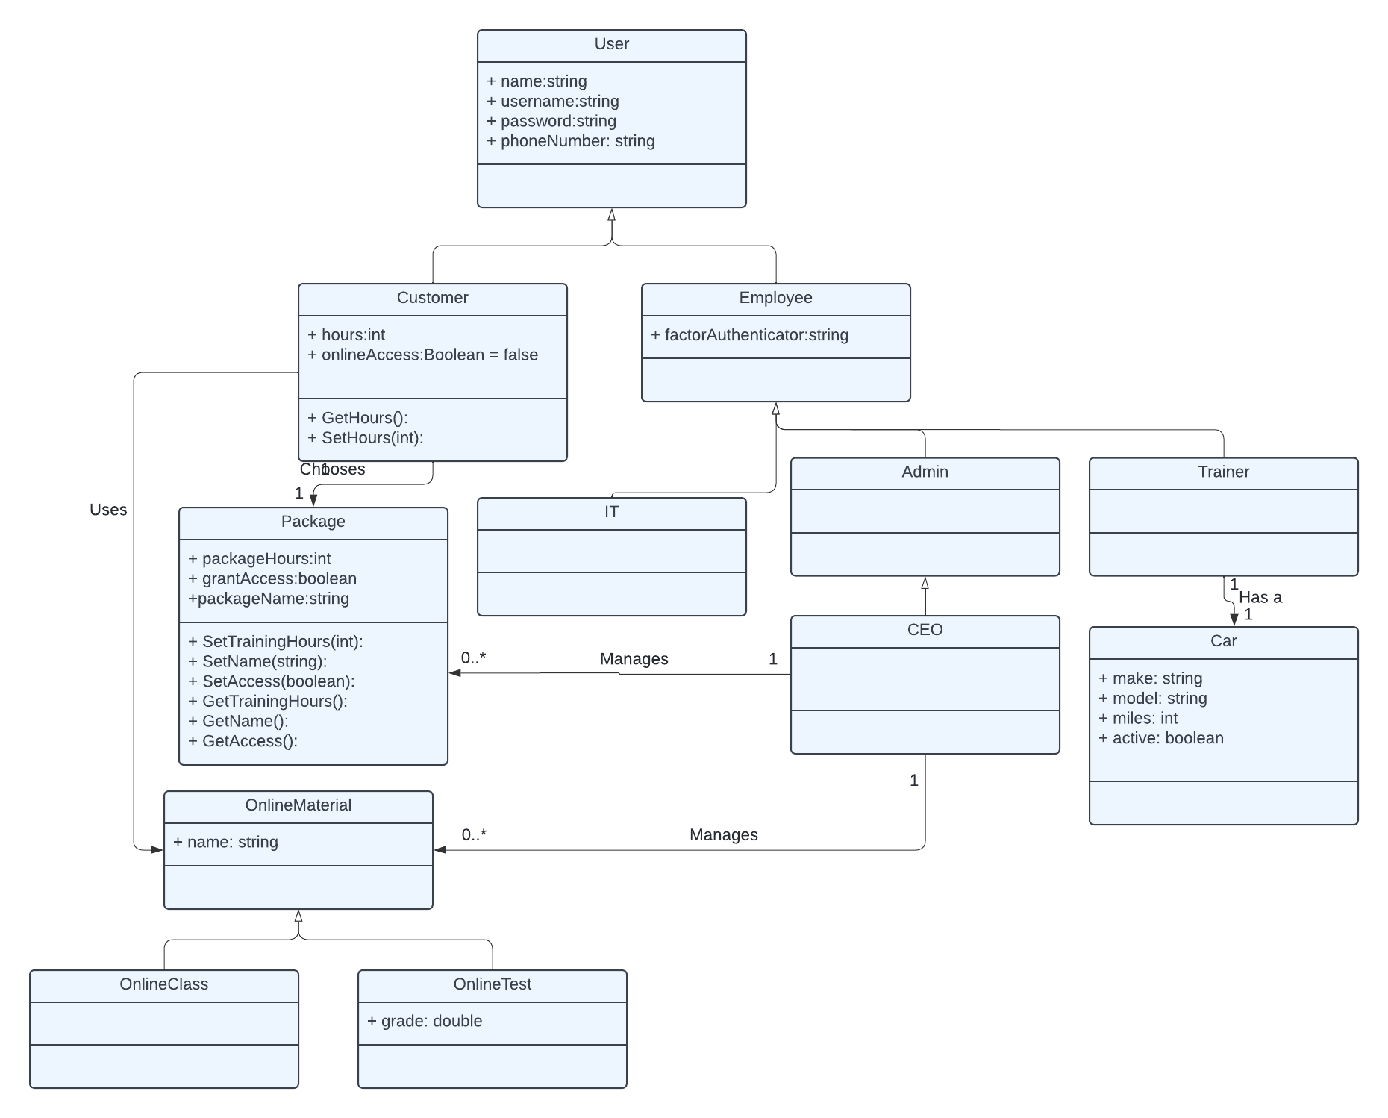

Technical Requirements
The DriverPass system will be web-based to give users access on multiple types of devices. It will be hosted on a cloud server to help with quick and easy scalability. An SQL database will be used to hold information on all users. The operating system will be Linux; this is a secure option, cheap, and easy to maintain. Latency does not need to be the fastest, but should also not be slow. Two factor authenticator will be used for employees, Windows Authenticator recommended.

